# **Groundedness of codes (number of quotations coded by a code)**

|  | **Code** | **Grounded** | **Code Groups** |
| --- | --- | --- | --- |
| ● | responsibility/ownership sharing | 26 | SHARING |
| ● | collaboration | 25 | CULTURE |
| ● | enabler (platform) team | 23 | ORGANIZATIONAL STRUCTURE |
| ● | cross-functionality/skills | 23 | SKILLS & ROLES |
| ● | organizational silos/conflicts | 18 | ORGANIZATIONAL STRUCTURE |
| ● | automated application life-cycle management | 16 | AUTOMATION |
| ● | devops (bridge) team | 15 | ORGANIZATIONAL STRUCTURE |
| ● | role definition/attributions | 13 | SKILLS & ROLES |
| ● | platform servicing | 13 | AUTOMATION |
| ● | team self-organization & autonomy | 11 | MANAGEMENT |
| ● | knowledge sharing | 10 | SHARING |
| ● | transfer of work between teams | 10 | MANAGEMENT |
| ● | alignment of dev & ops goals | 7 | SHARING |
| ● | communication | 6 | CULTURE |
| ● | values & best practices | 5 | CULTURE |
| ● | delivery performance | 5 | MONITORING |
| ● | cultural silos/conflicts | 5 | CULTURE |
| ● | automated infrastructure management | 4 | AUTOMATION |
| ● | platform builder | 4 | AUTOMATION |
| ● | end-to-end product vision | 4 | MONITORING |
| ● | evangelization and mentoring | 4 | SKILLS & ROLES |
| ● | small size teams (two pizza rule) | 3 | ORGANIZATIONAL STRUCTURE |
| ● | hybrid (on-premises & cloud) | 3 | IT INFRASTRUCTURE |
| ● | leadership & management | 3 | MANAGEMENT |
| ● | rotary human resources | 3 | MANAGEMENT |
| ● | cloud | 2 | IT INFRASTRUCTURE |
| ● | on-premises | 1 | IT INFRASTRUCTURE |
| ● | containerization | 1 | IT INFRASTRUCTURE |

# **Groundedness of semantic domains (number of quotations coded by a semantic domain)**

|  | **Semantic Domain** | **Grounded** |
| --- | --- | --- |
| ● | ORGANIZATIONAL STRUCTURE | 59 |
| ● | CULTURE | 41 |
| ● | SHARING | 40 |
| ● | SKILLS & ROLES | 36 |
| ● | AUTOMATION | 34 |
| ● | MANAGEMENT | 26 |
| ● | MONITORING | 8 |
| ● | IT INFRASTRUCTURE | 7 |

# **Density of codes (number of relationships between codes – co-occurrence in the same quotation)**

## Co-occurrence table per code

| **● alignment of dev & ops goals Gr=7** | 0 | 0 | 0 | 0 | 2 | 3 | 0 | 2 | 1 | 0 | 0 | 0 | 0 | 0 | 0 | 0 | 0 | 0 | 4 | 0 | 0 | 2 | 1 | 0 | 0 | 0 | 0 | 0 | **15** |
| --- | --- | --- | --- | --- | --- | --- | --- | --- | --- | --- | --- | --- | --- | --- | --- | --- | --- | --- | --- | --- | --- | --- | --- | --- | --- | --- | --- | --- | --- |
| **● automated application life-cycle management Gr=16** | 0 | 0 | 0 | 0 | 4 | 1 | 0 | 2 | 0 | 3 | 2 | 3 | 1 | 0 | 0 | 3 | 0 | 1 | 3 | 0 | 3 | 1 | 0 | 0 | 0 | 1 | 1 | 1 | **30** |
| **● automated infrastructure management Gr=4** | 0 | 0 | 0 | 1 | 1 | 0 | 0 | 2 | 0 | 0 | 2 | 0 | 0 | 0 | 1 | 1 | 0 | 0 | 0 | 0 | 0 | 3 | 0 | 0 | 0 | 0 | 0 | 0 | **11** |
| **● cloud Gr=2** | 0 | 0 | 1 | 0 | 0 | 0 | 0 | 1 | 0 | 0 | 1 | 0 | 0 | 0 | 0 | 0 | 0 | 0 | 0 | 1 | 0 | 1 | 0 | 0 | 0 | 0 | 0 | 0 | **5** |
| **● collaboration Gr=25** | 2 | 4 | 1 | 0 | 0 | 0 | 1 | 4 | 0 | 1 | 2 | 2 | 1 | 1 | 0 | 3 | 0 | 0 | 7 | 0 | 3 | 7 | 6 | 0 | 0 | 2 | 3 | 0 | **50** |
| **● communication Gr=6** | 3 | 1 | 0 | 0 | 0 | 0 | 0 | 1 | 0 | 0 | 0 | 2 | 0 | 0 | 0 | 0 | 0 | 0 | 2 | 0 | 2 | 3 | 0 | 0 | 0 | 1 | 0 | 0 | **15** |
| **● containerization Gr=1** | 0 | 0 | 0 | 0 | 1 | 0 | 0 | 0 | 0 | 0 | 1 | 0 | 0 | 0 | 0 | 0 | 0 | 0 | 0 | 0 | 0 | 0 | 0 | 0 | 0 | 0 | 0 | 0 | **2** |
| **● cross-functionality/skills Gr=23** | 2 | 2 | 2 | 1 | 4 | 1 | 0 | 0 | 2 | 0 | 1 | 5 | 2 | 0 | 1 | 3 | 0 | 0 | 4 | 1 | 3 | 7 | 4 | 2 | 2 | 3 | 1 | 1 | **54** |
| **● cultural silos/conflicts Gr=5** | 1 | 0 | 0 | 0 | 0 | 0 | 0 | 2 | 0 | 0 | 0 | 0 | 1 | 0 | 0 | 0 | 0 | 0 | 4 | 0 | 0 | 1 | 0 | 0 | 0 | 1 | 1 | 0 | **11** |
| **● delivery performance Gr=5** | 0 | 3 | 0 | 0 | 1 | 0 | 0 | 0 | 0 | 0 | 0 | 1 | 1 | 0 | 0 | 0 | 0 | 0 | 1 | 0 | 0 | 1 | 0 | 0 | 0 | 3 | 0 | 0 | **11** |
| **● devops (bridge) team Gr=15** | 0 | 2 | 2 | 1 | 2 | 0 | 1 | 1 | 0 | 0 | 0 | 0 | 0 | 0 | 2 | 1 | 0 | 0 | 0 | 4 | 0 | 6 | 1 | 0 | 0 | 0 | 4 | 2 | **29** |
| **● enabler (platform) team Gr=23** | 0 | 3 | 0 | 0 | 2 | 2 | 0 | 5 | 0 | 1 | 0 | 0 | 0 | 4 | 0 | 4 | 1 | 0 | 0 | 0 | 13 | 4 | 1 | 3 | 0 | 4 | 0 | 3 | **50** |
| **● end-to-end product vision Gr=4** | 0 | 1 | 0 | 0 | 1 | 0 | 0 | 2 | 1 | 1 | 0 | 0 | 0 | 0 | 0 | 0 | 1 | 0 | 1 | 0 | 0 | 3 | 0 | 0 | 0 | 3 | 0 | 0 | **14** |
| **● evangelization and mentoring Gr=4** | 0 | 0 | 0 | 0 | 1 | 0 | 0 | 0 | 0 | 0 | 0 | 4 | 0 | 0 | 0 | 1 | 0 | 0 | 0 | 0 | 2 | 0 | 0 | 1 | 0 | 1 | 0 | 1 | **11** |
| **● hybrid (on-premises & cloud) Gr=3** | 0 | 0 | 1 | 0 | 0 | 0 | 0 | 1 | 0 | 0 | 2 | 0 | 0 | 0 | 0 | 0 | 0 | 0 | 0 | 1 | 0 | 1 | 0 | 0 | 0 | 0 | 1 | 1 | **8** |
| **● knowledge sharing Gr=10** | 0 | 3 | 1 | 0 | 3 | 0 | 0 | 3 | 0 | 0 | 1 | 4 | 0 | 1 | 0 | 0 | 1 | 0 | 1 | 0 | 0 | 1 | 2 | 0 | 0 | 0 | 0 | 1 | **22** |
| **● leadership & management Gr=3** | 0 | 0 | 0 | 0 | 0 | 0 | 0 | 0 | 0 | 0 | 0 | 1 | 1 | 0 | 0 | 1 | 0 | 0 | 0 | 0 | 0 | 1 | 1 | 0 | 1 | 0 | 0 | 0 | **6** |
| **● on-premises Gr=1** | 0 | 1 | 0 | 0 | 0 | 0 | 0 | 0 | 0 | 0 | 0 | 0 | 0 | 0 | 0 | 0 | 0 | 0 | 0 | 0 | 0 | 1 | 0 | 0 | 0 | 0 | 1 | 0 | **3** |
| **● organizational silos/conflicts Gr=18** | 4 | 3 | 0 | 0 | 7 | 2 | 0 | 4 | 4 | 1 | 0 | 0 | 1 | 0 | 0 | 1 | 0 | 0 | 0 | 0 | 1 | 2 | 1 | 0 | 0 | 4 | 1 | 0 | **36** |
| **● platform builder Gr=4** | 0 | 0 | 0 | 1 | 0 | 0 | 0 | 1 | 0 | 0 | 4 | 0 | 0 | 0 | 1 | 0 | 0 | 0 | 0 | 0 | 0 | 0 | 1 | 0 | 0 | 0 | 0 | 0 | **8** |
| **● platform servicing Gr=13** | 0 | 3 | 0 | 0 | 3 | 2 | 0 | 3 | 0 | 0 | 0 | 13 | 0 | 2 | 0 | 0 | 0 | 0 | 1 | 0 | 0 | 3 | 0 | 1 | 0 | 2 | 0 | 1 | **34** |
| **● responsibility/ownership sharing Gr=26** | 2 | 1 | 3 | 1 | 7 | 3 | 0 | 7 | 1 | 1 | 6 | 4 | 3 | 0 | 1 | 1 | 1 | 1 | 2 | 0 | 3 | 0 | 4 | 0 | 1 | 4 | 4 | 0 | **61** |
| **● role definition/attributions Gr=13** | 1 | 0 | 0 | 0 | 6 | 0 | 0 | 4 | 0 | 0 | 1 | 1 | 0 | 0 | 0 | 2 | 1 | 0 | 1 | 1 | 0 | 4 | 0 | 0 | 1 | 0 | 3 | 0 | **26** |
| **● rotary human resources Gr=3** | 0 | 0 | 0 | 0 | 0 | 0 | 0 | 2 | 0 | 0 | 0 | 3 | 0 | 1 | 0 | 0 | 0 | 0 | 0 | 0 | 1 | 0 | 0 | 0 | 0 | 1 | 0 | 1 | **9** |
| **● small size teams (two pizza rule) Gr=3** | 0 | 0 | 0 | 0 | 0 | 0 | 0 | 2 | 0 | 0 | 0 | 0 | 0 | 0 | 0 | 0 | 1 | 0 | 0 | 0 | 0 | 1 | 1 | 0 | 0 | 0 | 0 | 0 | **5** |
| **● team self-organization & autonomy Gr=11** | 0 | 1 | 0 | 0 | 2 | 1 | 0 | 3 | 1 | 3 | 0 | 4 | 3 | 1 | 0 | 0 | 0 | 0 | 4 | 0 | 2 | 4 | 0 | 1 | 0 | 0 | 0 | 0 | **30** |
| **● transfer of work between teams Gr=10** | 0 | 1 | 0 | 0 | 3 | 0 | 0 | 1 | 1 | 0 | 4 | 0 | 0 | 0 | 1 | 0 | 0 | 1 | 1 | 0 | 0 | 4 | 3 | 0 | 0 | 0 | 0 | 1 | **21** |
| **● values & best practices Gr=5** | 0 | 1 | 0 | 0 | 0 | 0 | 0 | 1 | 0 | 0 | 2 | 3 | 0 | 1 | 1 | 1 | 0 | 0 | 0 | 0 | 1 | 0 | 0 | 1 | 0 | 0 | 1 | 0 | **13** |

## 2- Density of codes

| **CODE** | **DENSITY** |
| --- | --- |
| **● responsibility/ownership sharing Gr=26** | **61** |
| **● cross-functionality/skills Gr=23** | **54** |
| **● collaboration Gr=25** | **50** |
| **● enabler (platform) team Gr=23** | **50** |
| **● organizational silos/conflicts Gr=18** | **36** |
| **● platform servicing Gr=13** | **34** |
| **● team self-organization & autonomy Gr=11** | **30** |
| **● devops (bridge) team Gr=15** | **29** |
| **● role definition/attributions Gr=13** | **26** |
| **● knowledge sharing Gr=10** | **22** |
| **● transfer of work between teams Gr=10** | **21** |
| **● communication Gr=6** | **15** |
| **● end-to-end product vision Gr=4** | **14** |
| **● values & best practices Gr=5** | **13** |
| **● automated infrastructure management Gr=4** | **11** |
| **● cultural silos/conflicts Gr=5** | **11** |
| **● delivery performance Gr=5** | **11** |
| **● evangelization and mentoring Gr=4** | **11** |
| **● rotary human resources Gr=3** | **9** |
| **● hybrid (on-premises & cloud) Gr=3** | **8** |
| **● platform builder Gr=4** | **8** |
| **● leadership & management Gr=3** | **6** |
| **● cloud Gr=2** | **5** |
| **● small size teams (two pizza rule) Gr=3** | **5** |
| **● on-premises Gr=1** | **3** |
| **● containerization Gr=1** | **2** |

## Charts for codes with greater density

# **Density of semantic domains (number of relationships between semantic domains – co-occurrence in the same quotation)**

## 1- Co-occurrence table per semantic domain

| **● AUTOMATION Gr=34** | 0 | 12 | 5 | 4 | 3 | 25 | 10 | 10 |
| --- | --- | --- | --- | --- | --- | --- | --- | --- |
| **● CULTURE Gr=41** |  | 0 | 2 | 10 | 3 | 24 | 18 | 15 |
| **● IT INFRASTRUCTURE Gr=7** |  |  | 0 | 2 | 0 | 4 | 3 | 2 |
| **● MANAGEMENT Gr=26** |  |  |  | 0 | 6 | 17 | 10 | 10 |
| **● MONITORING Gr=8** |  |  |  |  | 0 | 3 | 4 | 2 |
| **● ORGANIZATIONAL STRUCTURE Gr=59** |  |  |  |  |  | 0 | 21 | 18 |
| **● SHARING Gr=40** |  |  |  |  |  |  | 0 | 18 |
| **● SKILLS & ROLES Gr=36** |  |  |  |  |  |  |  | 0 |

## 2- Density of semantic domains

| **SEMANTIC DOMAIN** | **DENSITY** |
| --- | --- |
| ● ORGANIZATIONAL STRUCTURE Gr=59 | 112 |
| ● CULTURE Gr=41 | 84 |
| ● SHARING Gr=40 | 84 |
| ● SKILLS & ROLES Gr=36 | 75 |
| ● AUTOMATION Gr=34 | 69 |
| ● MANAGEMENT Gr=26 | 59 |
| ● MONITORING Gr=8 | 21 |
| ● IT INFRASTRUCTURE Gr=7 | 18 |

## 3- Charts for semantic domains with greater density

# **Networks**

## Network – Semantic Domains

## Network1 – From “responsibility/ownership sharing”

## Network2 – From cross-functionality/skills

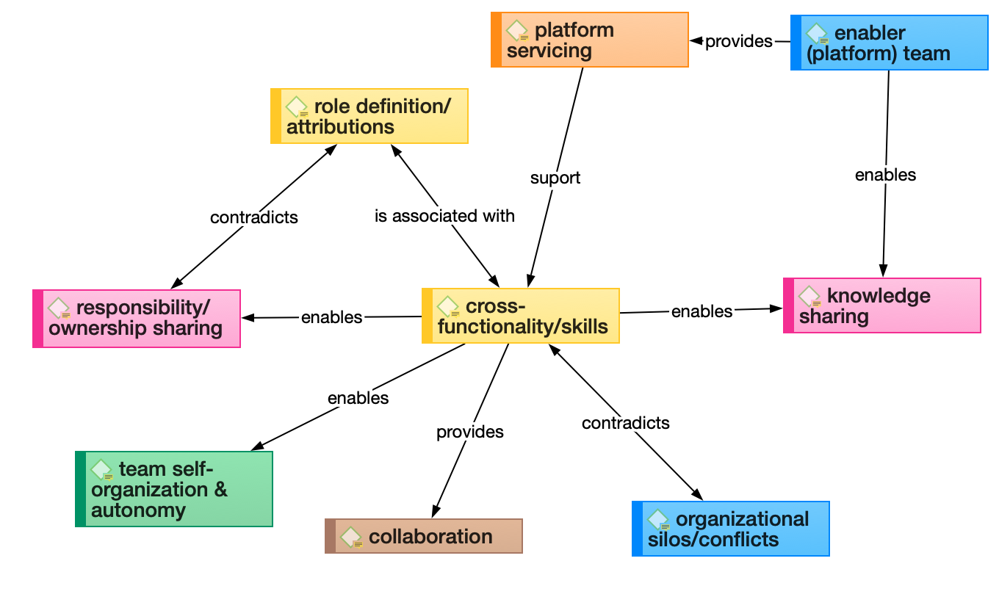

## Network 3 – From collaboration

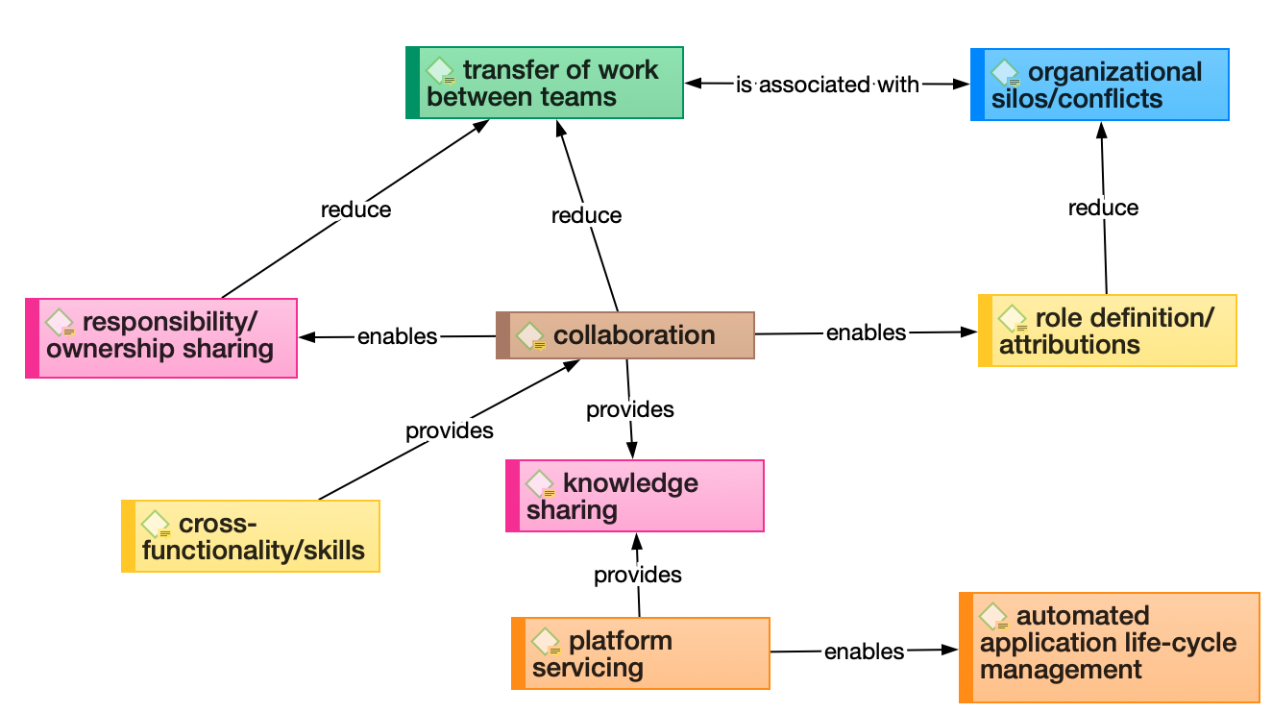

## Network4 – From enabler (platform) team

# **SELECTION OF CORE CATEGORIES**

Based on the analysis of groundedness and density, the core categories are:

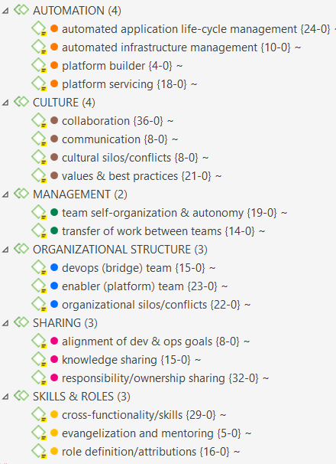

This means, the semantic domains **MONITORING** & **IT INFRASTRUCTURE** (and their 6 codes) were deleted from codebook together with the codes **leadership & management**; **rotary human resources**; and **small size teams (two pizza rule)**. Thus, a total of 9 codes were deleted from the codebook. Currently, the codebook is composed of 6 semantic domains and 19 codes.

See the document selection of core categories – codebook.pdf

# **Analysis per document**

